Ideation Phase

The ideation phase plays a critical role in shaping the foundation of the Motor Temperature Prediction project. This phase focuses on understanding the real-world problem, identifying user needs, exploring possible solutions, and clearly defining the problem statement. To achieve this systematically, the ideation phase is divided into three key sub-phases: Brainstorming, Empathy Mapping, and Problem Statement Definition.

1. Brainstorming Phase
Brainstorming is the initial step of the ideation phase, where ideas are generated freely without immediate evaluation or constraints. The objective of this phase is to explore all possible aspects of the problem related to motor temperature monitoring and prediction.

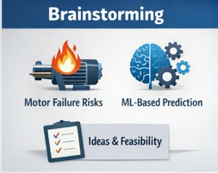
1.1 Identification of the Problem Domain
Electric motors are widely used in industrial machinery, electric vehicles, HVAC systems, and manufacturing plants. One of the major causes of motor failure is overheating, which can occur due to excessive load, environmental conditions, insulation degradation, or improper cooling mechanisms.
Traditional temperature monitoring systems often rely on:
- Periodic manual inspection
- Threshold-based alarms
- Physical temperature sensors placed at limited points
These methods have limitations such as delayed fault detection, sensor failures, and inability to predict future temperature trends.
1.2 Idea Generation
During brainstorming, the following key ideas were explored:
- Using machine learning models to predict motor temperature in advance
- Leveraging historical sensor data (current, voltage, speed, ambient temperature, torque, etc.)
- Reducing dependency on expensive or unreliable physical sensors
- Enabling predictive maintenance instead of reactive maintenance
- Improving motor lifespan and operational efficiency

1.3 Feasibility Considerations
The brainstorming phase also considered:
- Availability of real-world or benchmark datasets
- Suitability of regression-based ML algorithms
- Computational efficiency for real-time prediction
- Scalability for industrial applications
This phase helped narrow down the idea to a data-driven motor temperature prediction system using machine learning.

